Ravi Mann
ECE 362
Post-Lab # 3

Introduction:

The objective of this lab is to delve into crucial concepts in assembly programming for the HC(S)12 microcontroller. Through hands-on experimentation, I will gain proficiency in implementing arithmetic instructions, understanding scaling for precise numerical computations, and discerning the impact of signed and unsigned operations on the Condition Code Register (CCR). Additionally, I will develop the skills to craft a program that runs continuously on the I/O board. This lab serves as a comprehensive exploration of fundamental aspects of assembly programming, equipping you with a strong foundation for more complex applications in embedded systems development.

Lab 3.1.1:
Objective/Purpose:
Create an assembly language program that calculates the value of y in the given straight-line equation y = mx + b.

Explanation:
This program calculates the value of 'y' in the linear equation 'y = mx + b', using the provided constants 'Slope' (0.68 * 100) and 'Offset' (12).

Results:
The program performs arithmetic operations to calculate the result. The result is obtained by scaling the value 'VAL' by the slope factor and adding the offset. The result is stored in the memory location reserved for 'RESULT'.
Modifying Val using the data window in the debugger.

Val = 0 | Result: $C
Val = 10 | Result: $12
Val = 75 | Result: $3F
Val = 200 | Result: $9A
Val = 255 | Result: $B9

Code:
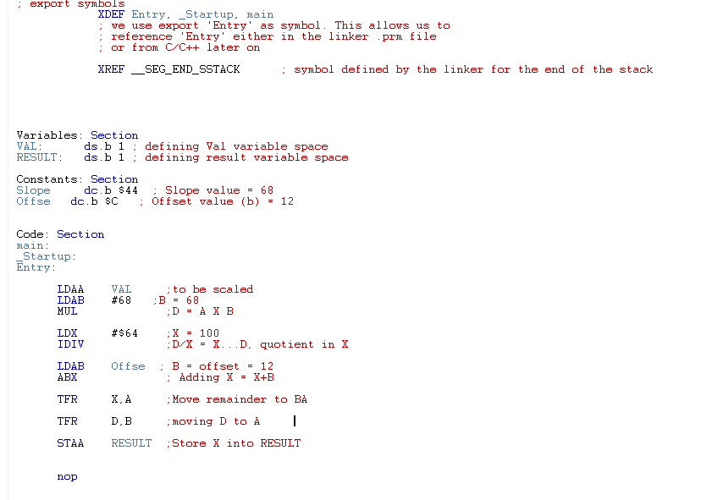

Lab 3.1.2:
Objective/Purpose:
The objective of this lab is to create an assembly language program that calculates the value of 'y' in the parabolic equation 'y = mx^2 + b', where 'm' is represented by the constant 'Slope' and 'b' is represented by the constant 'Offset'.

Explanation:
Val relocates 10 bytes of space for the x value. Then its squared with MUL. EMUL is used to multiply it with $44 and EDIV to convert it into decimal value. Finally, $C is added to the D and stored into RESULT label.

Results:
This program calculates the value of 'y' in the parabolic equation 'y = mx^2 + b', using the provided constants $44 and $C. The result is stored in the memory location reserved for 'RESULT'.
Modifying Val using the data window in the debugger.

Val = 0 Result: $C
Val = 10 Result: $50
Val = 75 Result: $EFD
Val = 200 Result: $6AAC
Val = 255 Result: $ACC5

Code:
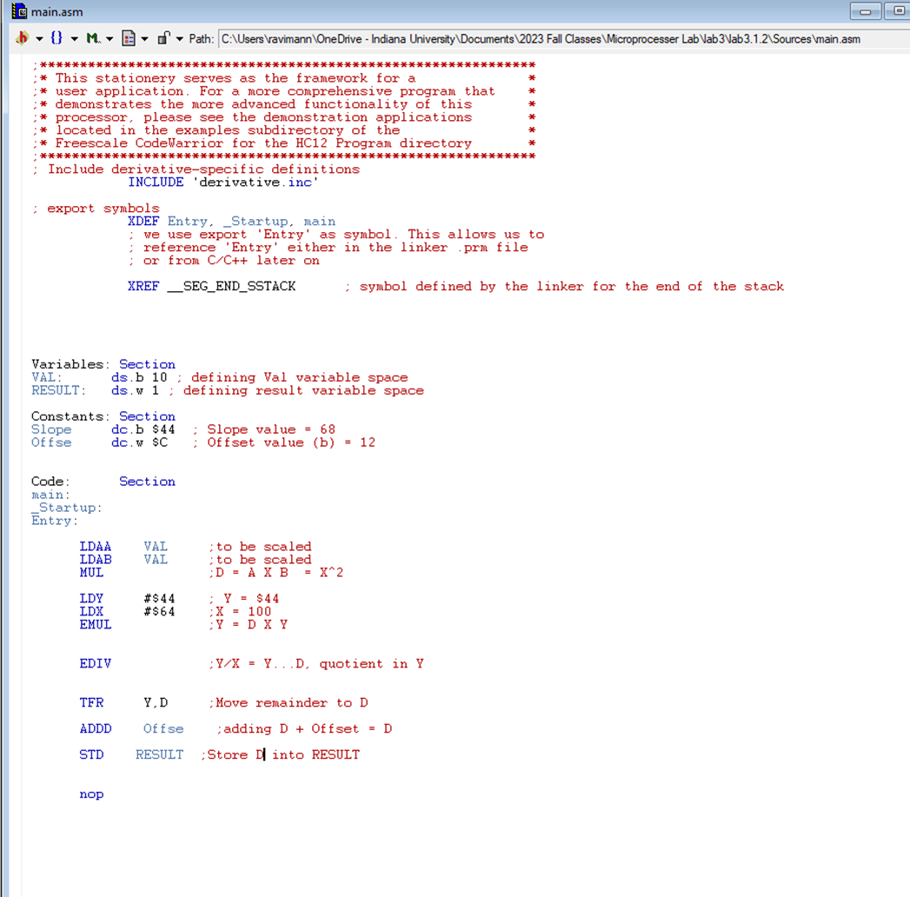

Lab 3.2.1:
Objective/Purpose:
The objective of this lab is to perform arithmetic operations using the accumulator in assembly language. Specifically, it involves loading accumulator A with a value from memory and then adding another value to it.

Explanation:
The program loads the value of num_1 into accumulator A using the instruction LDAA num_1. Next, it adds the value of num_2 to accumulator A with the instruction ADDA num_2.

Results:
After executing the code with num_1 = 0x40 and num_2 = 0x50:

Accumulator A after execution: $90
CCR:
Carry Flag (C) Set [ ] Clear [X]
Overflow Flag (V) Set [X ] Clear [ ]
Negative Flag (N) Set [ X] Clear [ ]
Zero Flag (Z) Set [ ] Clear [X ]

After changing num_1 to 0xF6 and num_2 to 0xEC:

Accumulator A after execution: $E2
CCR:
Carry Flag (C) Set [X ] Clear [ ]
Overflow Flag (V) Set [ ] Clear [X ]
Negative Flag (N) Set [ ] Clear [X ]
Zero Flag (Z) Set [ ] Clear [X ]

After changing num_2 to 0x57:

Accumulator A after execution: $4D
CCR:
Carry Flag (C) | Set [ X] Clear [ ]
Overflow Flag (V) | Set [ ] Clear [ X]
Negative Flag (N) | Set [ ] Clear [ X]
Zero Flag (Z) | Set [ ] Clear [ X]

After changing num_1 to 0xE9 and num_2 to 0x89:

Accumulator A after execution: $72
CCR:
Carry Flag (C) | Set [X ] Clear [ ]
Overflow Flag (V) | Set [X ] Clear [ ]
Negative Flag (N) | Set [ ] Clear [X ]
Zero Flag (Z) | Set [ ] Clear [X ]

Changing both num_1 and num_2 to 0x3F and replacing ADDA with SUBA:

Accumulator A after execution: $D
CCR:
Carry Flag (C) | Set [ ] Clear [ X]
Overflow Flag (V) | Set [ ] Clear [ X]
Negative Flag (N) | Set [ ] Clear [ X]
Zero Flag (Z) | Set [ X] Clear [ ]
After changing num_2 to 0x90:

Accumulator A after execution: $AF
CCR:
Carry Flag (C) | Set [X ] Clear [ ]
Overflow Flag (V) | Set [X ] Clear [ ]
Negative Flag (N) | Set [ X] Clear [ ]
Zero Flag (Z) | Set [ ] Clear [X ]

Code:
XDEF Entry
XREF __SEG_END_SSTACK

Constants: Section
Num_1: dc.b $40
Num_2: dc.w $50

Code: Section

Entry:
LDAA Num_1 ;load $40 into A
ADDA Num_2 ;A = A+ num_2
nop

Lab 3.2.2:
Objective/Purpose:
The objective of this lab is to demonstrate the use of the CMPA instruction to compare the value in accumulator A with a specified variable without altering either value.

Explanation:
The program starts by loading the value 0x12 into accumulator A. It then defines a variable VAR_1 as a byte with an initial value of 0x30. Next, the program uses the CMPA instruction to compare the value in accumulator A with VAR_1. This comparison is done by effectively subtracting VAR_1 from the value in accumulator A, but the values themselves remain unchanged.

Results:
The CMPA instruction is commonly used for comparisons in assembly language. It allows the program to make decisions based on the relationship between two values without changing those values.

Accumulator A after execution: $12
CCR:
Carry Flag (C) Set [X ] Clear [ ]
Overflow Flag (V) Set [ ] Clear [ X]
Negative Flag (N) Set [ X] Clear [ ]
Zero Flag (Z) Set [ ] Clear [ X]

Code:
XDEF Entry
XREF __SEG_END_SSTACK

Constants: Section
VAR_1: dc.b $30

Code: Section

Entry:
LDAA #$12 ; Load value $12 into A
CMPA VAR_1 ; Compare A with VAR_1 ($30)
nop

Lab 3.2.3:
Objective/Purpose:

Explanation:
Explain briefly how your code works.
E.g.: The program takes values from register A, uses register B to do arithmetic operations with the value in A, stores the new value in a variable.
The more you comment on your code, the less you have to explain in here.

Results:
What did the code do? What was the output? What observations can you make?

The contents of Accumulator A after program with BVS and value of $D3 execution is $0. The contents of Accumulator A after program with BCS execution is $C5. The contents of Accumulator A after program with BVS and value of $41 execution is $9B

Code:
XDEF Entry
XREF __SEG_END_SSTACK

Code: Section

Entry:
LDAA #$D3 ; Load A with $D3
ADDA #$F2 ; Add $F2 to A
BVS done ; Branch if overflow flag (V) is set to done.
LDAA #0 ; Load 0 to A
done: nop

XDEF Entry
XREF __SEG_END_SSTACK

Code: Section

Entry:
LDAA #$D3 ; Load A with $D3
ADDA #$F2 ; Add $F2 to A
BCS done ; Branch if carry flag (C) is set to done.
LDAA #0 ; Load 0 to A
done: nop

XDEF Entry
XREF __SEG_END_SSTACK

Code: Section

Entry:
LDAA #$41 ; Load A with $41
ADDA #$5A ; Add $5A to A
BVS done ; Branch if overflow flag (V) is set to done.
LDAA #0 ; Load 0 to A
done: nop

Lab 3.3:
Objective/Purpose:
The objective of this lab is to write an assembly program to control a stepper motor connected to Port P.

Explanation:
The program starts by defining two variables. P_DDR sets bits 1 through 4 to 1, while leaving other bits unchanged. Array stores the motor stepping sequence. It loads the address of Array into the index register X. The loop iterates through the sequence. For each step, it loads the value from the sequence, outputs it to Port P, and then delays for 30 milliseconds. After the loop, it restores the Port P DDR to its original value.

Results:
The program will step the motor four times in a clockwise direction, as per the specified sequence. The program controls a stepper motor connected to Port P. It seems to use a specific sequence of values (0A, 12, 14, 0C) to step the motor. The program implements a delay between each step using a loop. The program does not have an explicit exit condition, which may result in continuous operation.
Code:
XDEF Entry
XREF __SEG_END_SSTACK

Constants: Section
Port_p Equ $258 ; Port_p address as $258
Ddr_p: Equ $25A ; DDr_p address as $25A
Array: dc.b $0A,$12,$14,$OC,$0 ;Array with motor sequence value

Code: Section

Entry:
LDAB #%00011110 ; Load B with 1 to 4 bits of Port_P_ddr
STAB Ddr_p ; Store value of B to Ddr_p

Array_loop: LDX #Array ; Load address of Array into X
Loop: LDAA 1, X+ ; Load value from X+1 into A and X=X+1
CMPA #0 ; Compare value of A with 0
BEQ Array_loop ; Branch to Array_loop if A = 0
STAA Port_p ; Output value to Port_p

LDY #30000 ; Load delay counter of 30 milliseconds
Delay: DEY ; decrement Y
BNE Delay ; Branch to Delay if Y != 0
BRA Loop ; Branch to loop

nop

Conclusion:

Concepts Learned:
This lab offered a thorough introduction to key ideas in HC(S)12 microcontroller assembly programming. Implementing arithmetic instructions became second nature to me, as did comprehending scaling for exact numerical calculations and recognizing the effects of signed and unsigned operations on the Condition Code Register (CCR). I also learnt how to program the I/O board to execute a program continually.
For the creation of embedded systems, these ideas are crucial. They make it possible for low-level programming to be exact in control and calculation, which is essential for jobs like interacting with hardware and sensors.
Concepts Not Fully Understood:
Although I understood the general ideas, I had some difficulty with the scaling part. For accurate results, it was necessary to understand how to scale numerical operations correctly, which took some more work and repetition.
Difficulties Encountered:
I had the most difficulty comprehending the scaling process. To get the desired outcome, it was necessary to have a better grasp of binary arithmetic and data manipulation techniques. Furthermore, considerable attention to detail was necessary to guarantee that the software operated continually on the I/O board without pausing or exhibiting unexpected behavior.

Overall, this lab gave me practical experience in assembly programming that was really helpful, and I now have greater faith in my abilities to use the HC(S)12 microcontroller in future projects.

